# 1、QOS

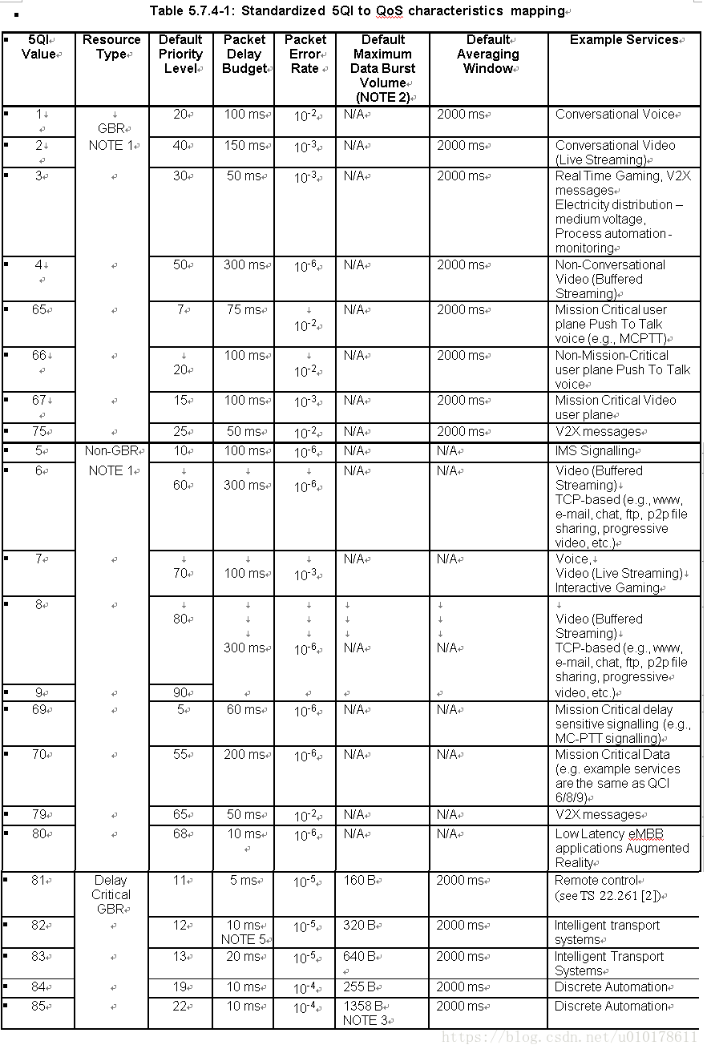

# 2.SSB

|  |  |  |  |
| --- | --- | --- | --- |
| **Table 5.4.3.3-1: Applicable SS raster entries per operating band** | | | |
| **NR operating band** | **SS Block SCS** | **SS Block pattern** | **Range of GSCN** |
| **(First – <Step size> – Last)** |
| n1 | 15 kHz | Case A | 5279 – <1> – 5419 |
| n2 | 15 kHz | Case A | 4829 – <1> – 4969 |
| n3 | 15 kHz | Case A | 4517 – <1> – 4693 |
| n5 | 15 kHz | Case A | 2177 – <1> – 2230 |
| 30 kHz | Case B | 2183 – <1> – 2224 |
| n7 | 15 kHz | Case A | 6554 – <1> – 6718 |
| n8 | 15 kHz | Case A | 2318 – <1> – 2395 |
| n12 | 15 kHz | Case A | 1828 – <1> – 1858 |
| n14 | 15 kHz | Case A | 1901 – <1> – 1915 |
| n18 | 15 kHz | Case A | 2156 – <1> – 2182 |
| n20 | 15 kHz | Case A | 1982 – <1> – 2047 |
| n25 | 15 kHz | Case A | 4829 – <1> – 4981 |
| n28 | 15 kHz | Case A | 1901 – <1> – 2002 |
| n29 | 15 kHz | Case A | 1798 – <1> – 1813 |
| n30 | 15 kHz | Case A | 5879 – <1> – 5893 |
| n34 | 15 kHz | Case A | 5030 – <1> – 5056 |
| n38 | 15 kHz | Case A | 6431 – <1> – 6544 |
| n39 | 15 kHz | Case A | 4706 – <1> – 4795 |
| n40 | 15 kHz | Case A | 5756 – <1> – 5995 |
| n41 | 15 kHz | Case A | 6246 – <3> – 6717 |
| 30 kHz | Case C | 6252 – <3> – 6714 |
| n48 | 30 kHz | Case C | 7884 – <1> – 7982 |
| n50 | 15 kHz | Case A | 3584 – <1> – 3787 |
| n51 | 15 kHz | Case A | 3572 – <1> – 3574 |
| n65 | 15 kHz | Case A | 5279 – <1> – 5494 |
| n66 | 15 kHz | Case A | 5279 – <1> – 5494 |
| 30 kHz | Case B | 5285 – <1> – 5488 |
| n70 | 15 kHz | Case A | 4993 – <1> – 5044 |
| n71 | 15 kHz | Case A | 1547 – <1> – 1624 |
| n74 | 15 kHz | Case A | 3692 – <1> – 3790 |
| n75 | 15 kHz | Case A | 3584 – <1> – 3787 |
| n76 | 15 kHz | Case A | 3572 – <1> – 3574 |
| n77 | 30 kHz | Case C | 7711 – <1> – 8329 |
| n78 | 30 kHz | Case C | 7711 – <1> – 8051 |
| n79 | 30 kHz | Case C | 8480 – <16> – 8880 |
| n90 | 15 kHz | Case A | 6246 – <1> – 6717 |
| 30 kHz | Case C | 6252 – <1> – 6714 |
| n91 | 15 kHz | Case A | 3572 – <1> – 3574 |
| n92 | 15 kHz | Case A | 3584 – <1> – 3787 |
| n93 | 15 kHz | Case A | 3572 – <1> – 3574 |
| n94 | 15 kHz | Case A | 3584 – <1> – 3787 |
| n257 | 120 kHz | Case D | 22388 - <1> - 22558 |
| 240 kHz | Case E | 22390 - <2> - 22556 |
| n258 | 120 kHz | Case D | 22257 - <1> - 22443 |
| 240 kHz | Case E | 22258 - <2> - 22442 |
| n260 | 120 kHz | Case D | 22995 - <1> - 23166 |
| 240 kHz | Case E | 22996 - <2> - 23164 |
| n261 | 120 kHz | Case D | 22446 - <1> - 22492 |
| 240 kHz | Case E | 22446 - <2> - 22490 |

|  |  |  |
| --- | --- | --- |
| 场景 | 子载波间隔 | 配置位置 |
| Case A | 15KHz | {2, 8} + 14*n |
| n=0, 1 f<=3GHz |
| n=0,1,2,3 3GHz<f<=6GHz |
| Case B | 30KHz | {4, 8, 16, 20} + 28*n |
| n = 0 f<=3GHz |
| n= 0,1 3GHz<f<=6GHz |
| Case C | 30KHz | {2, 8} + 14*n |
| n=0, 1 f<=3GHz |
| n=0,1,2,3 3GHz<f<=6GHz （FDD），TDD 2.6G  2,8,16,22,30,36,44,50 |
| Case D | 120KHz | {4, 8, 16, 20} + 28*n{4, 8, 16, 20} + 28*n |
| n=0, 1, 2, 3, 5, 6, 7, 8, 10, 11, 12, 13, 15, 16, 17, 18 6GHz<f |
| Case E | 240KHz | {8, 12, 16, 20, 32, 36, 40, 44} + 56*n |
| n=0, 1, 2, 3, 5, 6, 7, 8 6GHz<f |

S=P*2μ S=5

μ=1，P=2.5，

SCS=15*2μ 30KHz

11120

|  |  |  |  |  |
| --- | --- | --- | --- | --- |
| **D--1** | **D--1** | **D--1** | **S--2** | **U--0** |

|  |  |  |  |  |  |  |  |  |  |  |  |  |  |
| --- | --- | --- | --- | --- | --- | --- | --- | --- | --- | --- | --- | --- | --- |
| **0** | **1** | **2** | **3** | **4** | **5** | **6** | **7** | **8** | **9** | **10** | **11** | **12** | **13** |
| **14** | **15** | **16** | **17** | **18** | **19** | **20** | **21** | **22** | **23** | **24** | **25** | **26** | **27** |
| **28** | **29** | **30** | **31** | **32** | **33** | **34** | **35** | **36** | **37** | **38** | **39** | **40** | **41** |
| **42** | **43** | **44** | **45** | **46** | **47** | **48** | **49** | **50** | **51** | **52** | **53** | **54** | **55** |
| **56** | **57** | **58** | **59** | **60** | **61** | **62** | **63** | **64** | **65** | **66** | **67** | **68** | **69** |

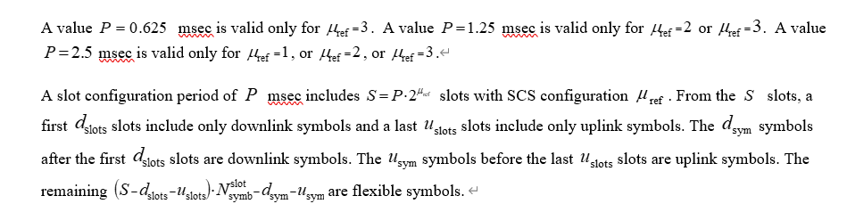3、SRS

|  |  | |  | |  | |  | |
| --- | --- | --- | --- | --- | --- | --- | --- | --- |
|  |  |  |  |  |  |  |  |  |
| 0 | 4 | 1 | 4 | 1 | 4 | 1 | 4 | 1 |
| 1 | 8 | 1 | 4 | 2 | 4 | 1 | 4 | 1 |
| 2 | 12 | 1 | 4 | 3 | 4 | 1 | 4 | 1 |
| 3 | 16 | 1 | 4 | 4 | 4 | 1 | 4 | 1 |
| 4 | 16 | 1 | 8 | 2 | 4 | 2 | 4 | 1 |
| 5 | 20 | 1 | 4 | 5 | 4 | 1 | 4 | 1 |
| 6 | 24 | 1 | 4 | 6 | 4 | 1 | 4 | 1 |
| 7 | 24 | 1 | 12 | 2 | 4 | 3 | 4 | 1 |
| 8 | 28 | 1 | 4 | 7 | 4 | 1 | 4 | 1 |
| 9 | 32 | 1 | 16 | 2 | 8 | 2 | 4 | 2 |
| 10 | 36 | 1 | 12 | 3 | 4 | 3 | 4 | 1 |
| 11 | 40 | 1 | 20 | 2 | 4 | 5 | 4 | 1 |
| 12 | 48 | 1 | 16 | 3 | 8 | 2 | 4 | 2 |
| 13 | 48 | 1 | 24 | 2 | 12 | 2 | 4 | 3 |
| 14 | 52 | 1 | 4 | 13 | 4 | 1 | 4 | 1 |
| 15 | 56 | 1 | 28 | 2 | 4 | 7 | 4 | 1 |
| 16 | 60 | 1 | 20 | 3 | 4 | 5 | 4 | 1 |
| 17 | 64 | 1 | 32 | 2 | 16 | 2 | 4 | 4 |
| 18 | 72 | 1 | 24 | 3 | 12 | 2 | 4 | 3 |
| 19 | 72 | 1 | 36 | 2 | 12 | 3 | 4 | 3 |
| 20 | 76 | 1 | 4 | 19 | 4 | 1 | 4 | 1 |
| 21 | 80 | 1 | 40 | 2 | 20 | 2 | 4 | 5 |
| 22 | 88 | 1 | 44 | 2 | 4 | 11 | 4 | 1 |
| 23 | 96 | 1 | 32 | 3 | 16 | 2 | 4 | 4 |
| 24 | 96 | 1 | 48 | 2 | 24 | 2 | 4 | 6 |
| 25 | 104 | 1 | 52 | 2 | 4 | 13 | 4 | 1 |
| 26 | 112 | 1 | 56 | 2 | 28 | 2 | 4 | 7 |
| 27 | 120 | 1 | 60 | 2 | 20 | 3 | 4 | 5 |
| 28 | 120 | 1 | 40 | 3 | 8 | 5 | 4 | 2 |
| 29 | 120 | 1 | 24 | 5 | 12 | 2 | 4 | 3 |
| 30 | 128 | 1 | 64 | 2 | 32 | 2 | 4 | 8 |
| 31 | 128 | 1 | 64 | 2 | 16 | 4 | 4 | 4 |
| 32 | 128 | 1 | 16 | 8 | 8 | 2 | 4 | 2 |
| 33 | 132 | 1 | 44 | 3 | 4 | 11 | 4 | 1 |
| 34 | 136 | 1 | 68 | 2 | 4 | 17 | 4 | 1 |
| 35 | 144 | 1 | 72 | 2 | 36 | 2 | 4 | 9 |
| 36 | 144 | 1 | 48 | 3 | 24 | 2 | 12 | 2 |
| 37 | 144 | 1 | 48 | 3 | 16 | 3 | 4 | 4 |
| 38 | 144 | 1 | 16 | 9 | 8 | 2 | 4 | 2 |
| 39 | 152 | 1 | 76 | 2 | 4 | 19 | 4 | 1 |
| 40 | 160 | 1 | 80 | 2 | 40 | 2 | 4 | 10 |
| 41 | 160 | 1 | 80 | 2 | 20 | 4 | 4 | 5 |
| 42 | 160 | 1 | 32 | 5 | 16 | 2 | 4 | 4 |
| 43 | 168 | 1 | 84 | 2 | 28 | 3 | 4 | 7 |
| 44 | 176 | 1 | 88 | 2 | 44 | 2 | 4 | 11 |
| 45 | 184 | 1 | 92 | 2 | 4 | 23 | 4 | 1 |
| 46 | 192 | 1 | 96 | 2 | 48 | 2 | 4 | 12 |
| 47 | 192 | 1 | 96 | 2 | 24 | 4 | 4 | 6 |
| 48 | 192 | 1 | 64 | 3 | 16 | 4 | 4 | 4 |
| 49 | 192 | 1 | 24 | 8 | 8 | 3 | 4 | 2 |
| 50 | 208 | 1 | 104 | 2 | 52 | 2 | 4 | 13 |
| 51 | 216 | 1 | 108 | 2 | 36 | 3 | 4 | 9 |
| 52 | 224 | 1 | 112 | 2 | 56 | 2 | 4 | 14 |
| 53 | 240 | 1 | 120 | 2 | 60 | 2 | 4 | 15 |
| 54 | 240 | 1 | 80 | 3 | 20 | 4 | 4 | 5 |
| 55 | 240 | 1 | 48 | 5 | 16 | 3 | 8 | 2 |
| 56 | 240 | 1 | 24 | 10 | 12 | 2 | 4 | 3 |
| 57 | 256 | 1 | 128 | 2 | 64 | 2 | 4 | 16 |
| 58 | 256 | 1 | 128 | 2 | 32 | 4 | 4 | 8 |
| 59 | 256 | 1 | 16 | 16 | 8 | 2 | 4 | 2 |
| 60 | 264 | 1 | 132 | 2 | 44 | 3 | 4 | 11 |
| 61 | 272 | 1 | 136 | 2 | 68 | 2 | 4 | 17 |
| 62 | 272 | 1 | 68 | 4 | 4 | 17 | 4 | 1 |
| 63 | 272 | 1 | 16 | 17 | 8 | 2 | 4 | 2 |